# DAY 4 : Morning Assessment

1. What is a function in Python?

A function in Python is a block of reusable code that performs a specific task when called.

1. How do you define a function in Python?

You define a function using the def keyword.



1. How do you call a function in Python?

def greet():

print("Hello, world!")

greet()

1. What is the purpose of the `return` statement?

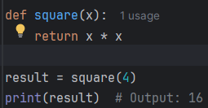

1. Write a function to add two numbers and return the result.

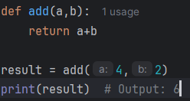

1. What is the difference between parameters and arguments?

Parameters are the variables listed in the function definition.

Arguments are the actual values passed when calling the function.

1. What happens if you define a function but never call it?

Nothing will happen. The function exists, but the code inside it won't run until you call it.

1. Write a function to check if a number is even or odd.

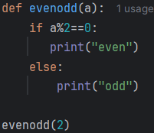

1. What is a default argument in a function? Give an example.

A default argument is a value that a parameter takes if no argument is provided during the call.

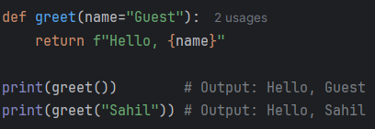

1. What is a keyword argument?

When calling a function, if you specify the parameter name along with its value, it is a keyword argument.

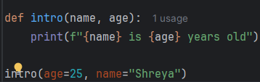

1. Write a function with a default argument.



1. Write a function that returns the square of a number.

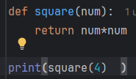

1. Can a function return multiple values? Give an example.

Yes, Python functions can return multiple values as a tuple.

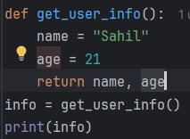

1. What is the difference between `print()` and `return` inside a function?

print() just shows something on the screen.

return sends data **back to the caller** so it can be used later.

1. What is a global variable?

A global variable is declared outside functions and can be accessed from inside any function.

1. What is a local variable inside a function?

A local variable is defined inside a function and only accessible within that function. It doesn't exist outside.

1. Write a function that accepts name and age and prints them.

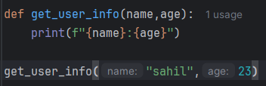

1. What is the use of the `pass` statement in a function?

pass is a do-nothing statement used when you want to write a function but not implement it yet. It avoids syntax errors.

1. Write a lambda function to multiply two numbers.

A **lambda function** is a small, anonymous function. Here it takes two arguments and returns their product.

output: 20

1. Write a function that calculates the factorial of a number using recursion.

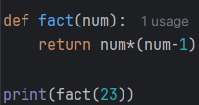

1. What is a while loop?

A while loop in Python is used to execute a block of code **repeatedly as long as a condition is** True.

1. Write a while loop that prints numbers from 1 to 5.

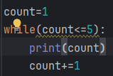

1. What is an infinite while loop?

An infinite while loop is a loop that never ends because its condition always remains True.

1. How do you stop an infinite while loop?

You can stop an infinite loop using a **break** statement.

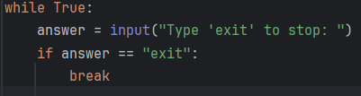

1. Write a while loop to print even numbers between 1 and 10.

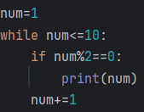

1. What is the difference between `for` and `while` loops?

For loop is used when we know the number of iterations. And we can use range() to run for loop  
while loop is used when you don't know how many times, but repeat until a condition is false

1. How do you use a break statement in a while loop?

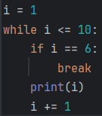

1. How do you use a continue statement in a while loop?

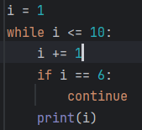

1. Write a program to sum numbers from 1 to 100 using a while loop.

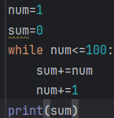output: 5050

1. Write a while loop that asks the user for input until they type “exit”.

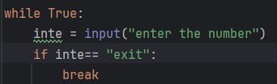 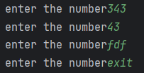

1. What is the purpose of initializing a variable before a while loop?

You need to initialize loop control variables before the loop starts so that the condition can be properly checked and updated.

If you don’t initialize, you'll get a NameError because variable would be undefined.

1. Write a while loop to print the multiplication table of 5.

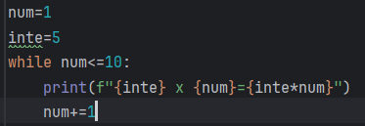

1. What happens if the condition of a while loop is always true?

It becomes an infinite loop. The loop will never stop unless there's a break or manual interruption.

1. How can you create a countdown from 10 to 1 using a while loop?

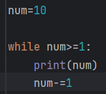

1. Write a while loop that prints only odd numbers from 1 to 20.

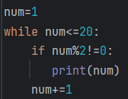

1. Can you use else with a while loop? Give an example.

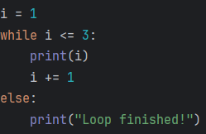

The else block executes only if the loop ends normally (not by break).

1. Write a while loop to reverse a number (e.g., input 123, output 321).

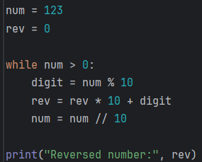output: Reversed number: 321

1. What is the importance of updating the condition inside a while loop?

If you **don’t update** the variable controlling the loop, the condition might **always remain true**. This causes an **infinite loop.**

1. Write a while loop that calculates the factorial of a number.

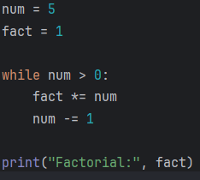output: Factorial: 120

1. Write a program using while loop to check if a number is a palindrome.

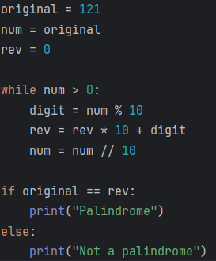output: palindrome